From: <https://www.science.org/content/article/polio-eradication-program-faces-hard-choices-endgame-strategy-fails>

Polio eradication program faces hard choices as endgame strategy falters

“All options are on the table” to fight alarming rise in vaccine-derived outbreaks

30 DEC 2019 BY: LESLIE ROBERTS

Polio vaccinators in northwestern Nigeria, where the live-virus vaccine itself is causing new infections.

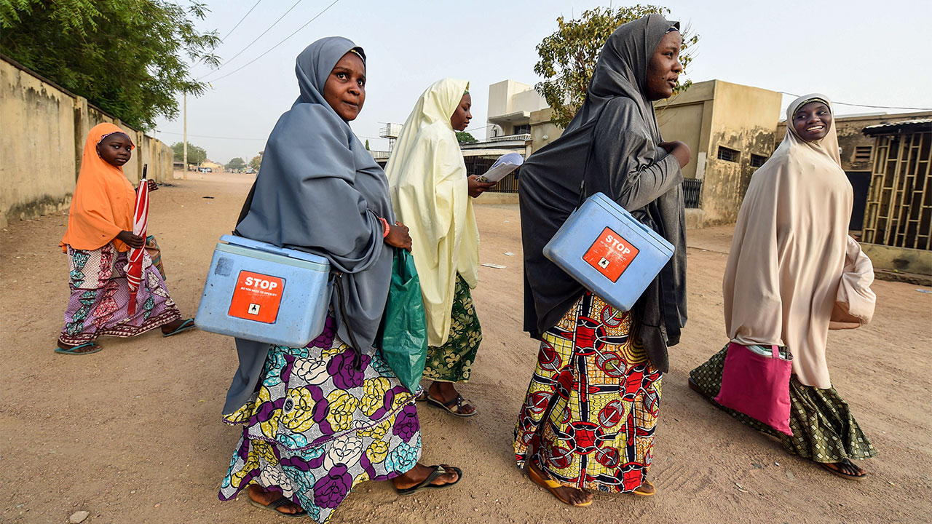

The "endgame" in the decadeslong campaign to eradicate polio suffered major setbacks in 2019. While the effort lost ground in Afghanistan and Pakistan, which recorded 116 cases of wild polio—four times the number in 2018—an especially alarming situation developed in Africa. In 12 countries, 196 children were paralyzed not by the wild virus, but by a strain derived from a live vaccine that has regained its virulence and ability to spread. Fighting these flare-ups will mean difficult decisions in the coming year.

The culprit in Africa is vaccine-derived polio virus type 2, and the fear is that it will jump continents and reseed outbreaks across the globe. A brand new vaccine is now being rushed through development to quash type 2 outbreaks. Mass production has already begun, even though the vaccine is still in clinical trials; it could be rolled out for emergency use as early as mid-2020. At the same time, the Global Polio Eradication Initiative (GPEI) is debating whether to combat the resurgent virus by re-enlisting a triple-whammy vaccine pulled from global use in 2016. That would be a controversial move, setting back the initiative several years, as well as a potential public relations disaster—an admission that the carefully crafted endgame strategy has failed.

"All options are on the table," says viro-logist Mark Pallansch of the U.S. Centers for Disease Control and Prevention, one of the five partner organizations in GPEI. "We are clearly in the most serious situation we have been in with the program," adds Roland Sutter, who recently stepped down as the director of polio research at the World Health Organization (WHO).

The heart of the problem is the live oral polio vaccine (OPV), the workhorse of the eradication program—the only polio vaccine powerful enough to stop viral circulation. Given as two drops into a child's mouth, OPV for decades contained a mix of three weakened polio viruses, one for each of the three wild serotypes that have long plagued humanity. All three serotypes in the vaccine have the potential to revert to more dangerous versions; that's why the endgame strategy calls for deploying OPV in massive campaigns to eradicate the wild virus, then ending its use entirely.

Wild serotype 2 was last sighted in 1999, so in 2016, as a first step in the endgame, all 155 countries using OPV replaced the trivalent version with a bivalent one, lacking the type 2 component. Announced with great fanfare, "the switch" was billed as the biggest vaccine rollout ever. Some type 2 outbreaks would inevitably occur for several years, GPEI realized, but those would be fought, somewhat paradoxically, by rushing in essentially the same vaccine that gave rise to them in the first place: a live, monovalent vaccine targeted against type 2 (mOPV2). If used in well-run campaigns, and only in outbreak regions, mOPV2 could stop outbreaks without seeding new ones, models suggested.

It often has not turned out that way. Instead of fading away, the number of type 2 outbreaks in Africa almost tripled from 2018 to 2019. Most of today's outbreaks stem from mOPV2 responses to previous ones, and GPEI is burning through its emergency stockpile of mOPV2 faster than it can be replenished. (Based on a small study in Mozambique, a WHO advisory panel recently recommended halving the dose to one drop if supplies run critically low, despite what it calls "a relatively weak level of evidence" that the smaller dose is as effective.) Meanwhile, the risk of explosive outbreaks around the globe is ratcheting up, because millions of children born since the switch have little or no immunity to type 2 virus.

WHO's Michel Zaffran, who leads GPEI, says there's room to make better use of mOPV2 by detecting outbreaks sooner, getting money and vaccines to countries earlier, and reaching more children. "There are things we can do even without a new tool," agrees Jay Wenger of the Bill & Melinda Gates Foundation, a partner in GPEI.

But hopes are pinned on a novel OPV (called nOPV2) that doesn't revert so easily. A Gates-funded research consortium is developing two candidates, each with changes at multiple nucleotides to increase genetic stability. Small phase I clinical trials suggested both trigger an immune response and are safe and unlikely to regain virulence. Phase II studies are underway in Belgium and Panama, but GPEI has already started to manufacture one candidate and hopes to have at least 100 million doses available this summer. GPEI is also pushing for an Emergency Use Listing, a never-before-used WHO mechanism that would enable the program to deploy the vaccine while it collects more data.

It's a risky strategy. The vaccine could fail or be delayed, and it won't solve all the problems. It won't be better at stopping outbreaks, just less likely to seed new ones. How much less likely remains to be seen. "Even if it is just 100 times safer, that will still be a big benefit," Wenger says, but the program is hoping for more.

Sutter worries GPEI is "putting all of its eggs into the nOPV basket." The novel vaccine could quickly lose its genetic stability if it exchanges key chunks of DNA with related viruses, he says. But how often these critical "recombination events" occur won't be known until the vaccine is used in larger populations. GPEI's Independent Monitoring Board noted recently that the program is "rather starry-eyed" about nOPV2's prospects.

If novel OPV2 doesn't work or vaccine-derived outbreaks spiral out of control before it is ready, the program might have little choice but to resurrect trivalent live vaccine, which would reintroduce immunity against type 2 in young children while maintaining protection against serotypes 1 and 3. The vaccine might be used in campaigns across Africa, reintroduced into routine immunization, or both.

The program is now struggling to define the "triggers" that would warrant this move. Is it reestablishment of type 2 across Africa? In Asia? The failure of nOPV2? The depletion of the mOPV2 emergency stockpile? "It is actually a hard question. … It's a public health judgment call," Wenger says. "People have different ideas on timing and triggers," Zaffran adds. But officials need to decide soon whether to ramp up production of trivalent OPV again, which could take several years.

Some experts fervently hope to avoid reintroduction of the trivalent vaccine. "It would be an enormous blow to the polio program and to international public health," says Nicholas Grassly, a modeler and epidemiologist at Imperial College London. Sutter, on the other hand, favors reintroduction sooner rather than later. Trivalent OPV "is the only thing we know has eradicated type 2 in the past and probably could eradicate it again," he says. But he agrees it would be a hard decision to communicate, given the huge global effort that went into persuading countries to switch to the bivalent vaccine in the first place. "How do we explain to the world that we have to go backward, not forward?" Sutter asks.

There's a bigger issue, too. No vaccine can stop polio if it doesn't get into children's mouths, program leaders and their advisers caution—and that has been a long-standing problem anywhere the virus, vaccine-derived or wild, still circulates. The polio eradication program has been struggling with complacency, fatigue, resistance, and poor planning—all human issues that technology can't fix.

***\*Correction, 16 January, 3:45 p.m.:****Due to an editing error, a previous version of this story incorrectly referred to the trivalent oral polio vaccine as OPV3.*

doi: 10.1126/science.aba7189